**Problem Statement 3: *Real-Time Data Experience with Fluvio***

**GREENHOUSE AGRI FARMING MONITORING**

A Project Documentation Submitted to

THE NAMESPACE COMMUNITY

For the fulfillment of the hackathon

**HACKHAZARDS’25**

Submitted by (Solo Performer):

**AANAND PANDIT**

aanandpandit0001@gmail.com

github.com/AanandPandit

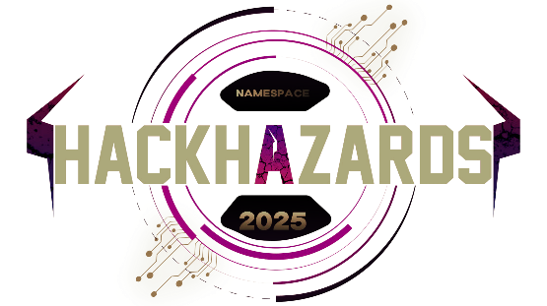



**HACKHAZARD’S 25**

Organized By

**THE NAMESPACE COMMUNITY**

**TABLE OF CONTENTS**

|  |  |  |
| --- | --- | --- |
| **Chapter** | **Title** | **Page** |
| **1** | **INTRODUCTION** | **3-4** |
|  | 1.1 Introduction | 3 |
|  | 1.2 Problem Statement | 3 |
|  | 1.3 Scope | 4 |
|  | 1.4 Objective | 4 |
| **2** | **DESIGN** | **5** |
|  | 2.1 System Architecture | 5 |
|  | 2.2 Technology Stack | 5 |
| **3** | **SETUP AND EXECUTION** | **6-7** |
| **4** | **RESULTS** | **8-12** |
| **5** | **FUTURE WORKS** | **13** |
| **6** | **IMPORTANT LINKS** | **14** |

**CHAPTER 1**

**INTRODUCTION**

**1.1 Introduction:**

The **Smart Greenhouse Monitoring System** is a real-time, data-driven simulation platform that demonstrates the integration of IoT, cloud-native streaming, and interactive dashboards to optimize greenhouse farming. Built with technologies like **Fluvio**, **PyQt5**, and **Flask**, it replicates a controlled agricultural environment where users can monitor and regulate essential parameters like temperature, humidity, CO₂ levels, soil moisture, water availability, lights, AC, humidifier, and all such devices that are installed in the greenhouse.

**Key Features:**

* **Real-Time Sensor Simulation**: Generates and streams live data for key environmental factors.
* **Dynamic Device Control**: Manage fans, lights, ACs, humidifiers, and water pumps through the dashboard.
* **Web Dashboard Interface**: Visualize sensor trends with interactive charts and receive instant system insights.
* **Fault Detection & Insights**: Automatically flags abnormal conditions (e.g., low moisture, high CO₂).
* **Resilient Connectivity**: Auto-reconnect logic ensures continued data flow even with network interruptions.
* **Modular Design**: Extensible architecture for integrating real sensors or expanding to physical farms.

**Benefits to Modern Farming:**

This system embodies the principles of **precision agriculture**—using technology to make farming smarter, more efficient, and data-informed. It reduces the need for constant human supervision, improves resource utilization (e.g., water, energy), and ensures healthier crop growth through timely interventions. By simulating this infrastructure, it lays the groundwork for scalable, intelligent farming systems suitable for both small-scale and industrial greenhouses.

**1.2 Problem Statement:**

**Problem Statement 3: *Real-Time Data Experience with Fluvio***

Traditional greenhouses often lack automated systems to manage environmental conditions. Manual monitoring leads to inefficiencies, resource waste, and inconsistent crop health. This project addresses the need for a smart, connected greenhouse system capable of real-time environmental sensing and automated device control.

**1.3 Scope:**

The system simulates sensor readings for temperature, humidity, CO₂, soil moisture, water level, and rainfall, alongside device controls for lights, fans, pumps, and ACs. The solution is intended for educational, prototype, and simulation purposes and can be extended for real hardware integration.

**1.4 Objective:**

* Simulate and visualize real-time greenhouse sensor data and device control mechanisms.
* Control greenhouse devices remotely through a web interface.
* Ensure continuous monitoring and insights using cloud-native streaming tools.
* Create an extensible platform for future real-environment deployments.

**CHAPTER 2**

**DESIGN**

The design consists of a PyQt5-based desktop simulation and a Flask web dashboard. Sensor and device interactions use Fluvio topics for producing and consuming data, mimicking a real greenhouse’s behavior. The design emphasizes modularity and clarity with structured UIs for sensors, devices, and logs.

**2.1 System Architecture:**

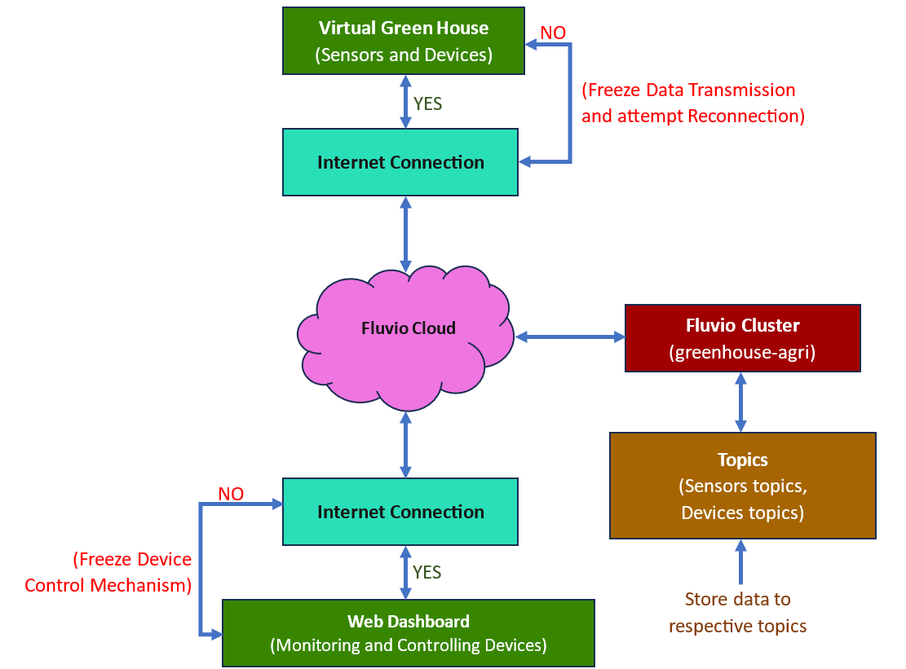

Fig.: High-Level System Architecture

**2.2 Technology Stack:**

|  |  |
| --- | --- |
| **Category** | **Technologies/Tools** |
| **Frontend** | HTML, CSS, JavaScript, Chart.js, PyQt5 |
| **Backend** | Python (Flask), Threads, Subprocess, Fluvio, Pytz |
| **Database** | Fluvio acts as transient data layer |
| **APIs** | RESTful APIs via Flask, Event-driven messaging via Fluvio |
| **Hosting** | Localhost (Fluvio and Flask) |

**CHAPTER 3**

**SETUP AND EXECUTION**

1. Clone the Repository:

‘git clone https://github.com/AanandPandit/hackhazards25_green-house-agri-farming.git’

cd hackhazards25_green-house-agri-farming

2. Install Fluvio Client:

sudo curl -fsS https://hub.infinyon.cloud/install/install.sh | bash

(After installing run this command to add path to system environment:)

echo 'export PATH="${HOME}/.fvm/bin:${HOME}/.fluvio/bin:${PATH}"' >> ~/.zshrc

(Reboot the system to take effect on changes of installation.)

sudo reboot

3. Login to InfinyOn Cloud:

fluvio cloud login

(Enter your InfinyOn Cloud email and password when prompted.)

4. Create and Setup the Cluster:

# Create cluster

fluvio cloud cluster create greenhouse-agri

# Check available clusters

fluvio profile list

# Set cluster for use

fluvio profile switch greenhouse-agri

# Check the current cluster

fluvio profile

5. Create Fluvio Topics:

fluvio topic create dht-temp

fluvio topic create dht-humid

fluvio topic create co2

fluvio topic create rain-sensor

fluvio topic create soil-moisture-1

fluvio topic create soil-moisture-2

fluvio topic create water-level-sensor

fluvio topic create fan-1

fluvio topic create fan-2

fluvio topic create fan-3

fluvio topic create fan-4

fluvio topic create fan-5

fluvio topic create ac-1

fluvio topic create ac-2

fluvio topic create humidifier-1

fluvio topic create humidifier-2

fluvio topic create humidifier-3

fluvio topic create light-1

fluvio topic create light-2

fluvio topic create light-3

fluvio topic create light-4

fluvio topic create light-5

fluvio topic create water-pump

6. Install Python Dependencies:

sudo pip3 install -r requirements.txt --break-system-packages

7. Run the Project:

Terminal 1: Start the Greenhouse Simulator:

cd greenhouse

python3 greenHouseSimulation.py

Terminal 2: Start the Dashboard:

cd webpage_dashboard

python3 app.py

8. View the Dashboad:

Open Firefox or any browser

Got to http://localhost:5000

(Interact with the dashboard and watch real-time changes in the simulator.)

NOTE:

More information at:

'https://github.com/AanandPandit/hackhazards25_green-house-agri-farming'

**CHAPTER 4**

**RESULTS**

The Smart Greenhouse Monitoring System successfully meets its goal of simulating a real-time, interactive, and intelligent farming environment. The system demonstrates the power of edge-native streaming and modular control in a simulated greenhouse setting.

**Functional Achievements:**

* **Sensor Simulation & Streaming**:
  + Multiple environmental parameters including temperature, humidity, CO₂, rain, soil moisture, and water tank levels were successfully simulated.
  + Real-time data was produced and streamed using **Fluvio topics**, ensuring consistent flow and low latency.
* **Interactive Dashboard:**
  + A web-based dashboard built with **Flask and Chart.js** displays **live graphs and current sensor values**.
  + **Color-coded** **insights** (e.g., ⚠️ High humidity) provide intuitive system health feedback for users.
* **Device Control & Feedback Loop:**
  + Users **can toggle fans, lights, humidifiers, ACs, and water pumps directly from the dashboard**.
  + **Device status (ON/OFF)** is visually reflected using icons and animation (e.g., .gif for active fans).
* **Resilience and Connectivity:**
  + The **PyQt5** simulator **auto-detects network loss** and attempts reconnection without restarting the system.
  + Device and sensor states remain consistent even after brief outages, showing robust fault tolerance.

**Performance Observations:**

* **Responsiveness**: Sensor readings and dashboard charts update within 1–2 seconds of data transmission.
* **Accuracy**: Simulated values follow realistic environmental ranges and show expected fluctuation.
* **Stability**: The system remained stable during prolonged runtime with no crashes or data loss.

**Usability and UI Feedback:**

* Clean, minimal interface in both the simulator and dashboard aids in usability.
* Users can understand the system state quickly through visual indicators, icons, and timestamps.
* Easy to extend and modify — new sensors or devices can be added with minimal code changes.

**Demonstrated Use Cases:**

* Real-time condition monitoring
* Device control automation
* Fault alerts for farming conditions
* Foundation for hardware-in-the-loop prototyping

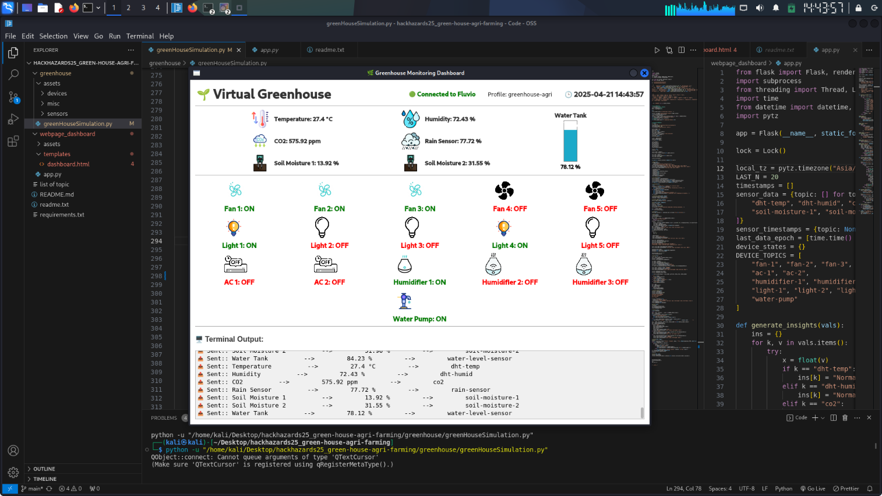

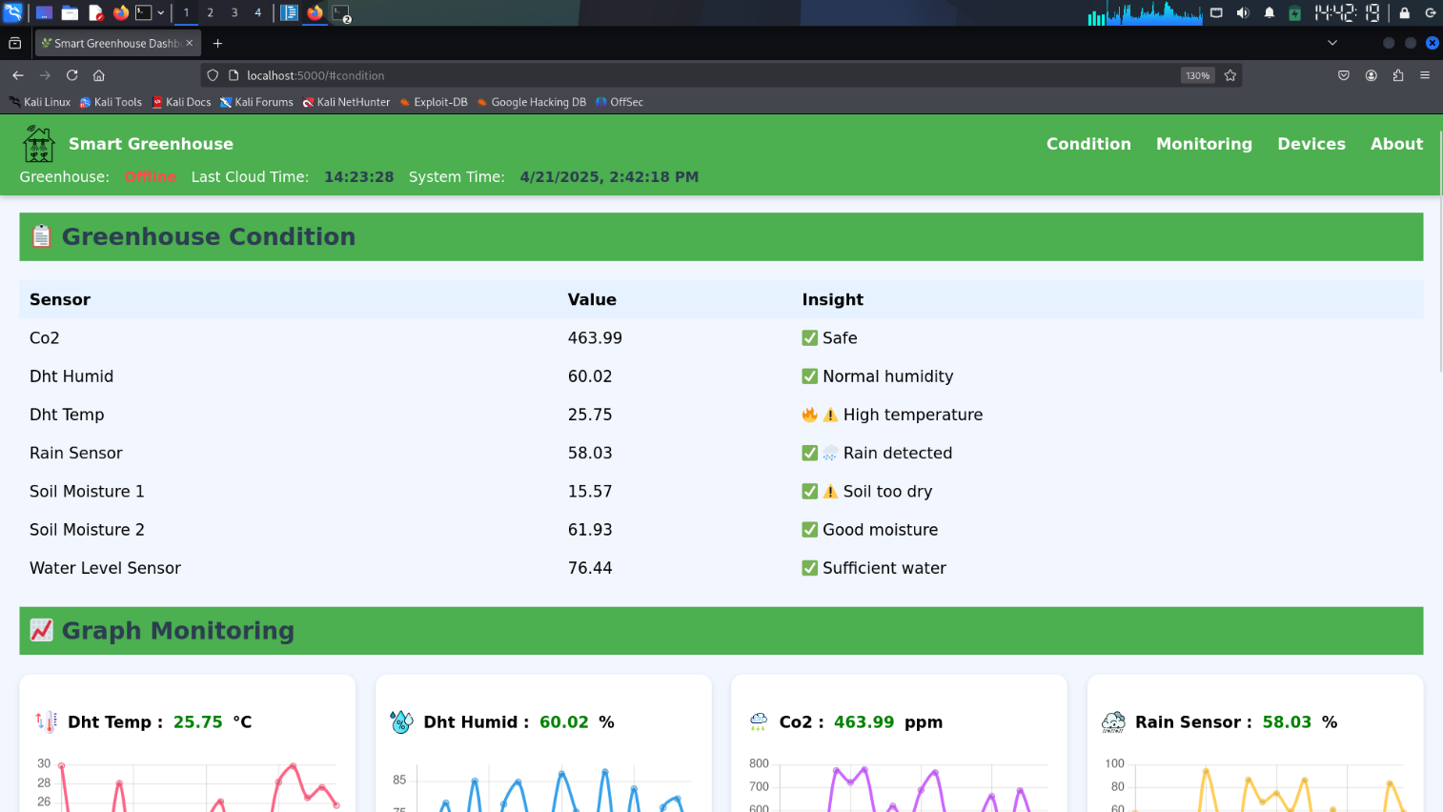

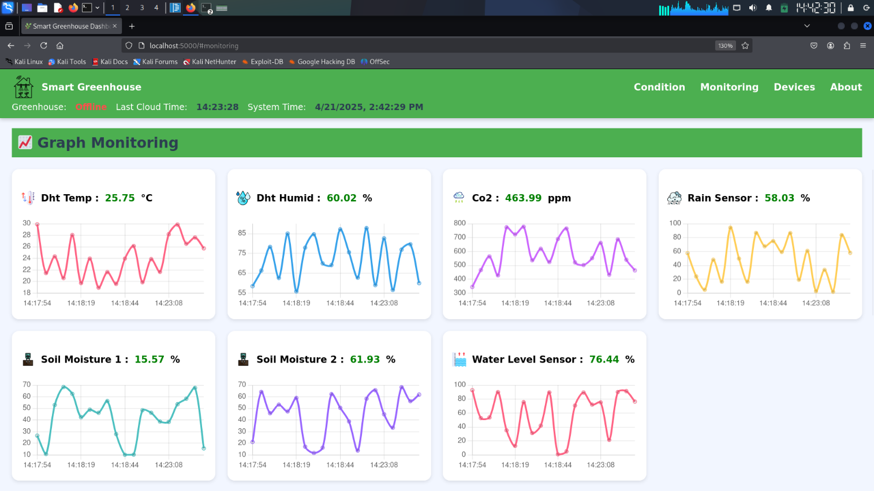

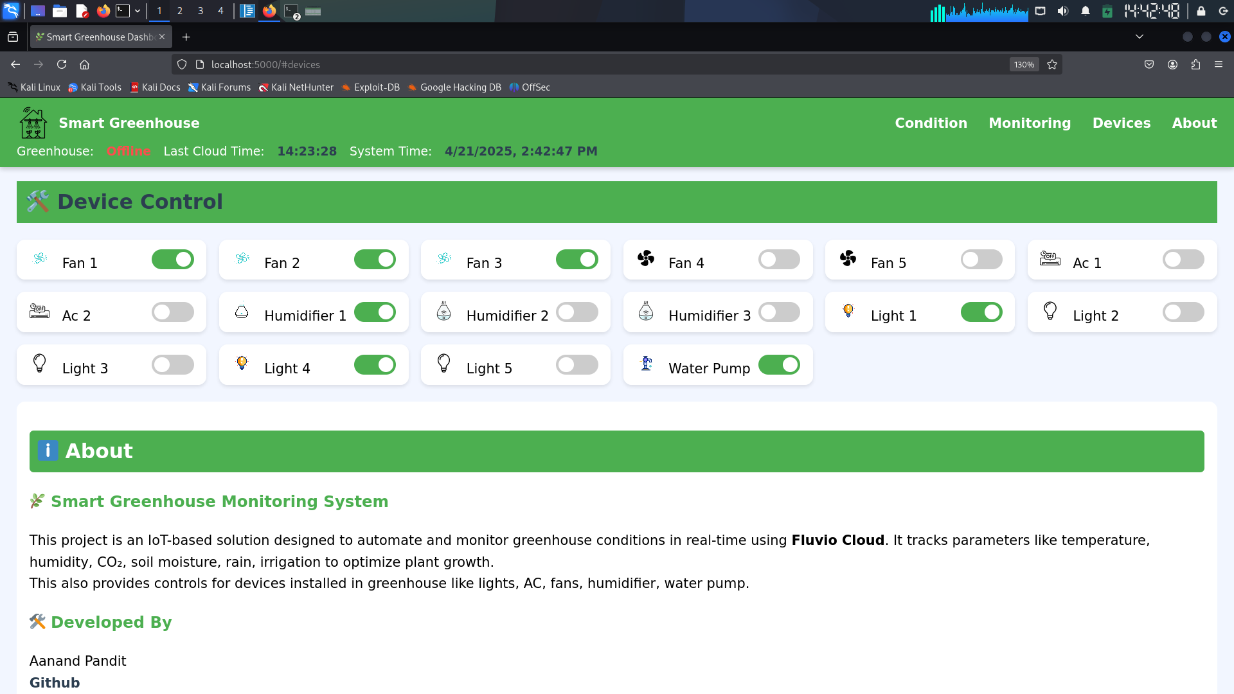

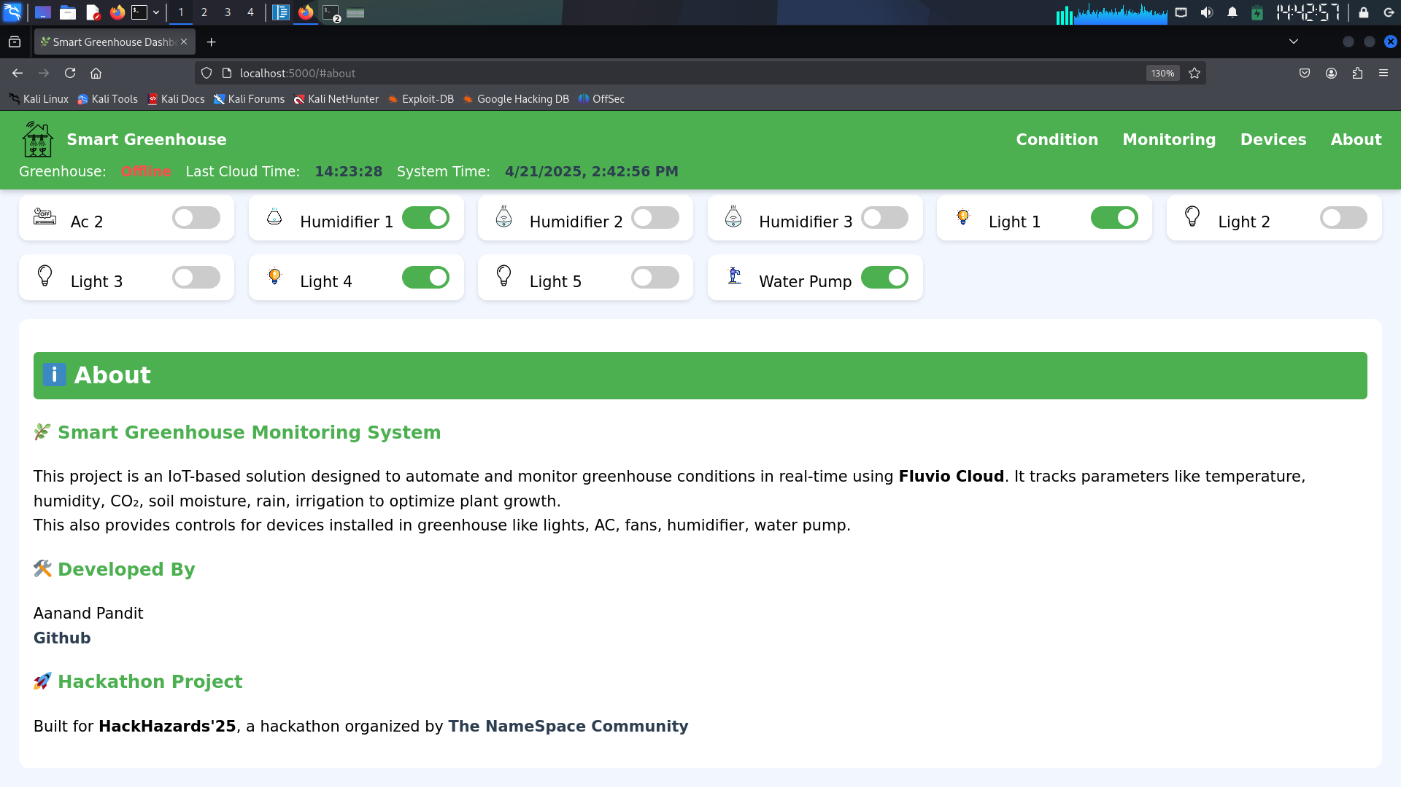

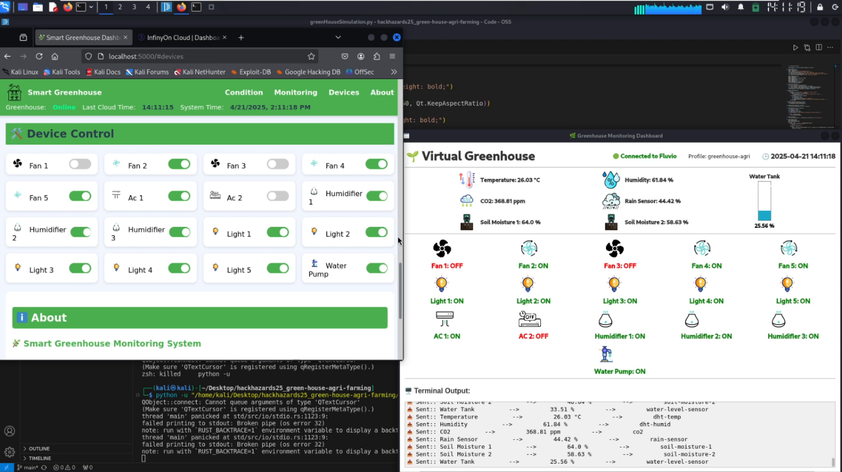

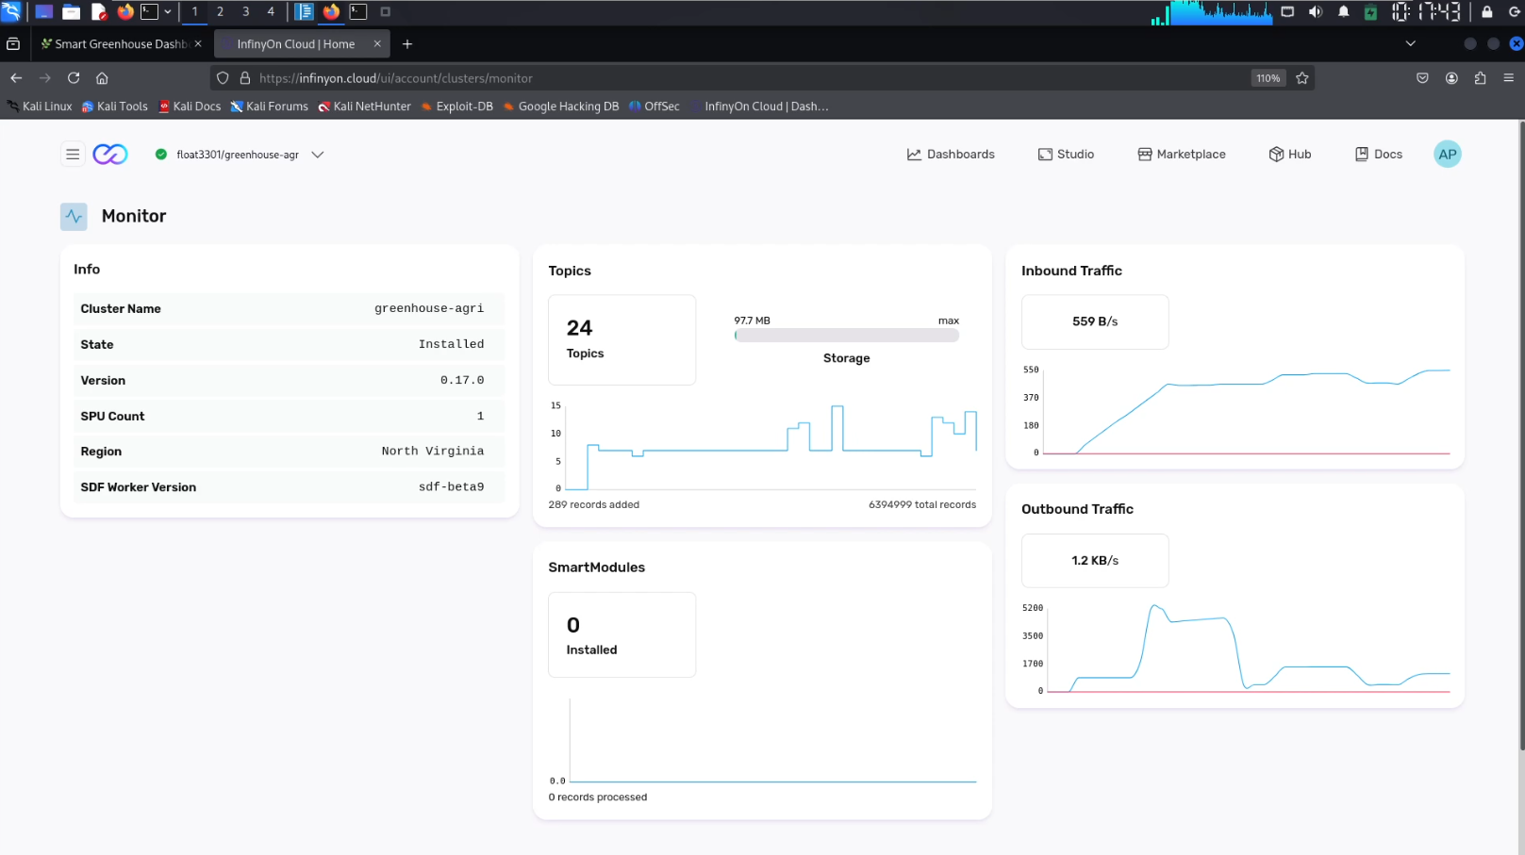

**CHAPTER 5**

**FUTURE WORKS**

While this project currently simulates a smart greenhouse environment, it is designed with real-world integration in mind. The following enhancements can evolve it from a virtual system to a fully functional greenhouse automation platform:

**1. Hardware Integration**

* Connect physical sensors (DHT11/22, soil moisture probes, CO₂ detectors, etc.) via **Raspberry Pi or Arduino**.
* Use relays and motor drivers to control actual devices like fans, pumps, lights, and humidifiers.

**2. IoT Edge Deployment**

* Deploy the PyQt5 simulator on edge devices (e.g., Raspberry Pi) for localized monitoring and control.
* Use **Fluvio’s** lightweight footprint to stream data from edge to cloud for central management.

**3. Cloud Analytics and Alerts**

* Integrate with cloud platforms (e.g., AWS, Azure IoT) for storage, analysis, and predictive farming.
* Add real-time alerts via SMS/Email when sensor thresholds exceed optimal conditions.

**4. Mobile App and Remote Control**

* Develop a mobile-friendly UI or app for farmers to monitor and control the system on the go.
* Use MQTT or REST APIs for secure remote operations.

**5. AI-Based Decision Making**

* Train ML models on collected data to automate irrigation, ventilation, and nutrient cycles.
* Enable adaptive behavior based on seasonal patterns or plant species.

This direction aligns with the vision of **smart agriculture**, ensuring sustainability, reduced waste, and improved yields through intelligent automation.

**CHAPTER 6**

**IMPORTANT LINKS**

1. Github:

[AanandPandit (AANAND PANDIT)](https://github.com/AanandPandit)

github.com/AanandPandit

1. Project Repo:

[AanandPandit/hackhazards25_green-house-agri-farming](https://github.com/AanandPandit/hackhazards25_green-house-agri-farming)

github.com/AanandPandit/hackhazards25_green-house-agri-farming

1. Devfolio:

[Aanand Pandit | Devfolio](https://devfolio.co/@float3301)

devfolio.co/@float3301

1. Sprint:

[sprint](https://www.sprint.dev/p/aanand)

sprint.dev/p/aanand

1. Linkedin:

[Aanand Pandit | LinkedIn](https://www.linkedin.com/in/aanand-pandit/)

1. Email: [aanandpandit0001@gmail.com](mailto:aanandpandit0001@gmail.com)
2. Fluvio:

[InfinyOn Cloud | Dashboard](https://infinyon.cloud/ui/account)

[Fluvio Community Documentation | Fluvio](https://www.fluvio.io/)

1. Contact: +91 9515525335

System architecture

Store data to respective topics

YES

NO

(Freeze Device Control Mechanism)

NO

**Virtual Green House**

(Sensors and Devices)

**Web Dashboard**

(Monitoring and Controlling Devices)

**Fluvio Cloud**

**Internet Connection**

**Internet Connection**

**Fluvio Cluster**

(greenhouse-agri)

**Topics**

(Sensors topics,

Devices topics)

YES

(Freeze Data Transmission and attempt Reconnection)